

**IBM NAAN MUDHALVAN**

**INTERNET OF THINGS**

**SMART RESTROOM – PHASE 5**

**TEAM MEMBERS**

HEMACHANDAR – 511321104029

DHANUSH KUMAR – 511321104022

MANNU – 511321104052

BHARATH – 511321104011

**Project Title: Smart Public Restrooms**

Project Overview: The Smart Public Restrooms project aims to enhance the quality of public restroom facilities by integrating cutting-edge technology and innovative management strategies. The project aims to improve user experience, optimize facility management, and promote hygiene in public restrooms through a range of smart features and data-driven decision-making.

Project Goals:

1. **Enhance User Experience:** To provide a more convenient, hygienic, and user-friendly experience for restroom visitors.
2. **Optimize Resource Management:** To streamline the allocation of cleaning staff and supplies while reducing operational costs.
3. **Promote Hygiene:** To ensure high levels of cleanliness and hygiene standards through real-time monitoring and alerts.
4. **Improve Accessibility:** To make public restrooms more accessible by providing location information and facility details to users.
5. **Data-Driven Decision Making:** To utilize data analytics for making informed decisions related to facility management and improvements.
6. **Safety and Emergency Response:** To enhance safety by providing location data in case of emergencies and enabling quick responses.

**Project Components:**

1. **Real-time Information System:** Installation of sensors and cameras to monitor restroom usage, cleanliness, and supply levels in real-time.
2. **User Interface:** Develop a user-friendly mobile application and signage within facilities to provide users with real-time information about available restrooms, cleanliness ratings, wait times, and other amenities.
3. **Feedback Mechanism:** Implement a feedback system in the mobile app to allow users to report issues and provide suggestions for improvement.
4. **Remote Monitoring:** Enable facility managers to access real-time data and receive alerts regarding any issues, allowing for quick responses to emergencies and maintenance needs.
5. **Predictive Maintenance:** Utilize data analytics to predict when maintenance and supply replenishment are needed, reducing downtime and improving user satisfaction.
6. **Resource Optimization:** Implement data-driven resource allocation to ensure that cleaning staff and supplies are efficiently distributed based on actual usage patterns.
7. **Security and Privacy:** Ensure that the system complies with data privacy regulations and includes security measures to protect user data.
8. **Emergency Response Integration:** Integrate the system with emergency services to provide location information during emergencies.

**Project Timeline:**

1. **Project Initiation:** Define project scope, objectives, and budget - 2 months.
2. **Technology Selection and Installation:** Procure necessary sensors, cameras, and software - 3 months.
3. **Development of Mobile App and User Interface:** Create the mobile app and design signage - 6 months.
4. **Implementation of Real-time Monitoring System:** Install sensors and cameras in public restrooms - 4 months.
5. **Data Analytics and Predictive Maintenance:** Develop algorithms for predictive maintenance - 6 months.
6. **User Testing and Feedback Mechanism Integration:** Test the system with real users and incorporate feedback - 3 months.
7. **Resource Allocation Optimization:** Implement data-driven resource allocation strategies - 4 months.
8. **Security and Privacy Assessment:** Ensure data security and privacy compliance - 2 months.
9. **Emergency Response Integration:** Collaborate with local emergency services - 3 months.
10. **Project Evaluation and Maintenance:** Continuously evaluate the system's performance and make necessary improvements - Ongoing.

Project Budget: The project budget includes expenses for technology procurement, development, installation, and ongoing maintenance. A detailed budget breakdown will be developed during the project initiation phase.

**MOBILE APP INTERFACE:**

Creating a mobile app interface for an IoT smart restroom involves designing user-friendly screens that provide real-time information about the restroom's status and features. Here's an outline of the key screens and components you can include in your app:

**1.Login/Registration:**

* **Login:** Users can log in using their credentials.
* **Registration:** New users can create an account.

**2. Dashboard:**

* **Map View:** Display a map with restroom locations.
* **Restroom List:** List nearby smart restrooms with key information.

**3. Restroom Details:**

* **Restroom Status:** Indicate if the restroom is open, occupied, or closed.
* **Environmental Conditions:** Display temperature, humidity, and air quality metrics.
* **Dispenser Status:** Show refill levels for soap and paper towels.
* **User Ratings and Reviews:** Allow users to read and leave reviews.
* **Report Issues:** Option to report problems like cleanliness or maintenance issues.

**4. Navigation:**

* **Menu:** Access user profile, settings, and additional features.
* **Search:** Allow users to search for specific restrooms.

**5. User Profile:**

* **Profile Picture:** Display the user's profile picture.
* **Username:** Show the username.
* **Ratings:** Display user's rating based on their reviews.
* **Favorites:** Option to add restrooms to favorites.
* **History:** Show the user's restroom visit history.

**6. Settings:**

* **Notification Preferences:** Allow users to customize push notifications.
* **App Language:** Option to change the app's language.
* **Privacy and Security:** Manage account security and data privacy settings.
* **Log Out:** Provide the option to log out.

**7. Notifications:**

* **Real-time Updates:** Notify users when the occupancy status changes in their favorite restrooms.
* **Refill Alerts:** Send alerts when dispenser refills are needed.

**8. Review Submission:**

* **Rate and Review:** Enable users to leave ratings and reviews for restrooms.
* **Add Photos:** Allow users to upload photos if desired.

**9. Search Results:**

* **Filtered Results:** Display restrooms based on user search criteria.
* **Sort and Filter Options:** Allow users to sort and filter search results.

**10. Error and Success Screens:**

* **Error Messages:** Display clear error messages if an action fails.
* **Success Confirmation:** Show success messages for actions like submitting reviews.

**11. Onboarding Screens:**

* **Intro Screens:** Provide informative screens for new users on the app's features.

**Real-time restroom information system can enhance user experience and restroom management.**

A real-time restroom information system can significantly enhance user experience and restroom management by providing valuable information and services to both restroom visitors and facility managers. Here's a breakdown of how it can benefit each group:

**Enhancing User Experience:**

1. **Accessibility:** Such a system can help users locate the nearest restroom easily, particularly in large public spaces like airports, shopping malls, or stadiums. Users can quickly find out which restrooms are available and how far away they are.
2. **Cleanliness and Maintenance:** Users can access real-time information about the cleanliness and maintenance status of restrooms. Knowing that a restroom has been recently cleaned or that maintenance is ongoing can increase user confidence in the facility's hygiene.
3. **Queue Management:** Users can check if a restroom is crowded or if there's a queue, enabling them to choose an alternative restroom with shorter waiting times.
4. **Amenities Information:** Users can access information about the facilities available in the restroom, such as baby-changing stations, accessible stalls, and vending machines for personal hygiene products.
5. **Smart Features:** Some advanced systems can offer hands-free entry using QR codes or mobile apps, reducing touchpoints and enhancing hygiene.
6. **Feedback Mechanism:** Users can provide feedback on their restroom experience, allowing facility managers to address issues promptly and improve services.

**Restroom Management:**

1. **Efficient Cleaning Schedules:** Real-time data on restroom usage can help facility managers optimize cleaning schedules. For example, restrooms that are used more frequently can be cleaned more often, while less-used restrooms can be cleaned less frequently, saving time and resources.
2. **Resource Allocation:** Insights from the system can help managers allocate resources like cleaning staff and supplies more efficiently, reducing operational costs.
3. **Predictive Maintenance:** Data on restroom usage can be analyzed to predict when maintenance, such as replenishing soap or changing paper towels, is needed, reducing downtime and improving user satisfaction.
4. **Capacity Planning:** The system can help managers plan for peak usage times, such as during events, by increasing the number of available restrooms or staff during those periods.
5. **Hygiene Monitoring:** Monitoring the cleanliness and supply levels in real-time ensures that hygiene standards are consistently met, reducing the risk of negative user experiences or health concerns.
6. **Safety:** In emergencies, such as fires or medical incidents, the system can help identify the location of users in restrooms, aiding in quick response and evacuation if necessary.
7. **Data Analytics:** Over time, the system can generate valuable data on restroom usage patterns, helping facility managers make data-driven decisions to improve user experiences and manage resources more effectively.

In conclusion, a real-time restroom information system benefits both users and facility managers by providing convenient, hygienic, and efficient restroom experiences. It can optimize resource allocation, improve cleanliness, and enhance user satisfaction, making it a valuable addition to public facilities.

**CODE:**

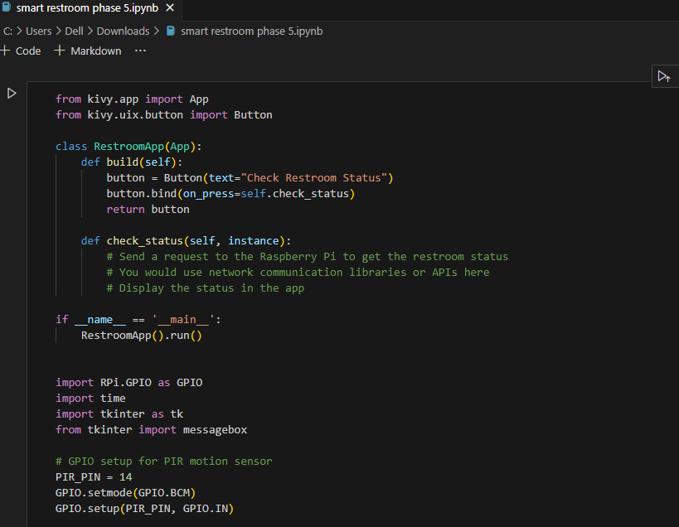

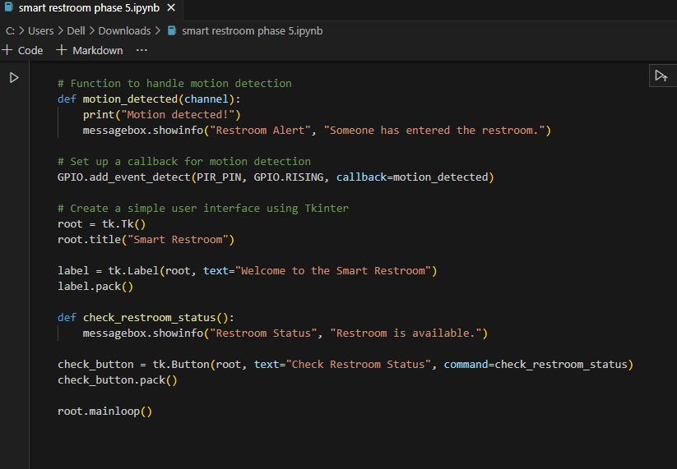

**CONCLUSION:**

In the conclusion, the implementation of a Smart Public Restroom project represents a significant leap forward in enhancing the quality and efficiency of public restroom facilities. By integrating technology, real-time monitoring, user feedback, and data-driven decision-making, these smart restrooms have the potential to provide a multitude of benefits.

The Smart Public Restroom project offers improved user experiences by making it easier for people to find clean and accessible restrooms and reducing wait times through real-time information. It also allows users to provide feedback and actively participate in the improvement of these facilities.

Moreover, safety and emergency response capabilities make these restrooms not only convenient but also secure spaces. In case of emergencies, real-time location data can be vital for quick responses and evacuations, potentially saving lives.